
Mains
Each meal for one side
- Bacon Cheeseburger (VIP)
Romaine Lettuce, Grill Turkey, Bacon, Cheddar cheese.
Rare/ medium rare/ medium/ medium well/ well done
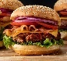
- BBQ burger (VIP)
Italian bake bread, Lettuce, tomato, BBQ beef, onion
(American cheese/cheddar)
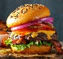
- Veggie burger (VIP)
Healthy vegetable with French bread, ketchup, American cheese.
(Grilled chicken)
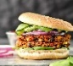
Sides
Dessert
- Ice cream
- Cup cake
- Oreo
- Pudding
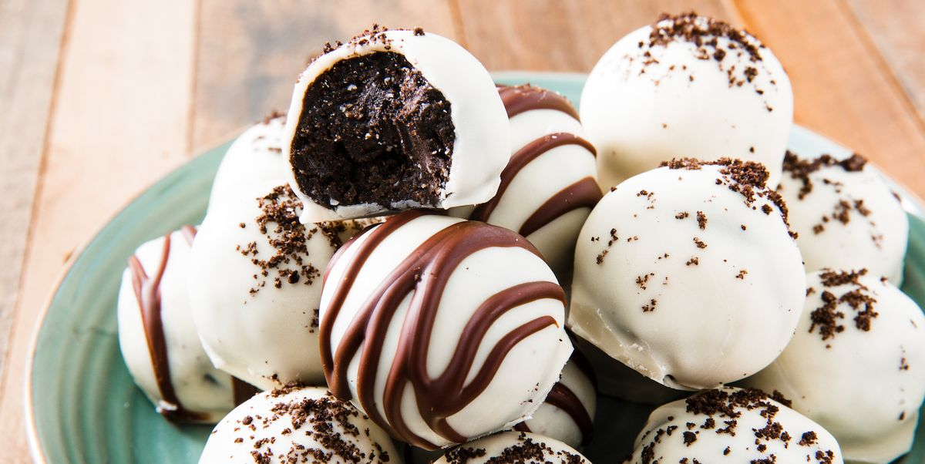
- French fired
- Chips
- Fresh fruits
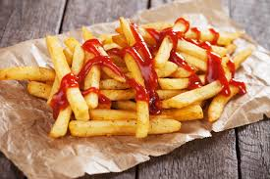

Drinks
- Coke
- Sprite
- Diet coke
- Milk tea
- Iced tea

