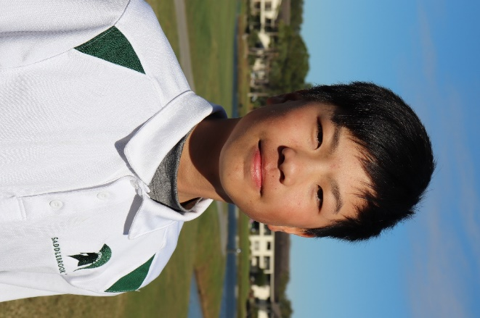
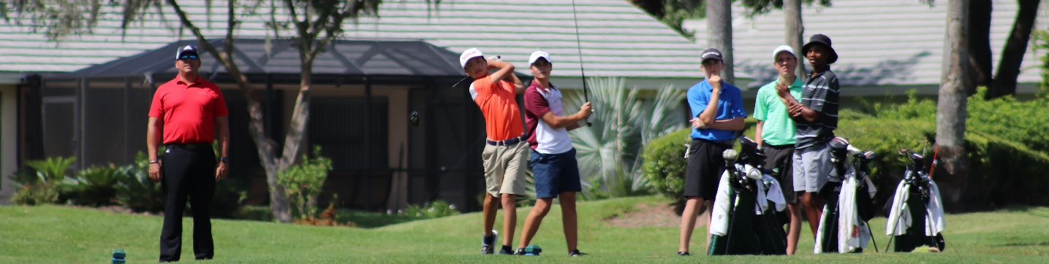
Yexing “Terry” Li
5700 Saddlebrook Way ● Wesley Chapel, FL 33543 ● Yexingli1003@gmail.com
https://yexingli1003.wixsite.com/mysite

Education
Age: 14
October 3, 2005
5’ 8”; 173 cm
112 lbs.; 51kg
Right-handed
Hunan, China
Score average 79.8
Driving average 230 yards
Coach Jan-Michael Norman jnorman@saddlebrook.com

High school: Saddlebrook Preparatory School 2019-Present
GPA: 3.8
SAT/ACT: N/K
Class of 2023

Tournaments
Tournament Course Scores Result
Ritz-Carlton, Academy Cup Ritz-Carlton 82-75 4
Academy Cup Celebration 79-85 15
Eagle Creek Eagle Creek 79-77 8
Mission Inn Mission Inn 82-79 1
National Championship ChampionsGate 79-82 19
DORAL Publix Junior Golf Classic Golden Course 87-80-79 32
Saddlebrook Saddlebrook 78-74 1

Awards and Achievements
Honor Roll January 2020

